Rutendo Demarema - SU210036V

A development of a responsive online marketplace for Adventist Entreprenuers

Submitted in Partial Fulfilment of the Requirements  
For the Degree of Computer & Management Information Systems : INSY 4

Solusi University

Faculty of Business Department of Computer & Management Information Systems



Contents

Chapter One: Introduction 2

1.1 Background 2

**1.2 Statement of the Problem** 2

1.2 Objectives 2

**1.4** **Methodology** 3

1.3 Feasibility Study 4

**1.6 Project Scope and limitations** 5

**1.7 Significance of the Research** 5

**1.8 Organisation of the project** 5

**1.9 Conclusion to This Chapter** 6

Chapter Two: Analysis 7

1.1 Existing System 7

1.2 New System 7

Chapter Three: Design 21

3.1 Purpose and goals of design 21

3.2 Current software architecture 21

3.3. Proposed Software Architecture 22

Chapter Four: Implementation 26

Chapter Five: Testing and Evaluation 27

5.1. System Testing 27

# Chapter One: Introduction

## Background

Effective trading in a digital world requires digital markets, and as such, an online market place platform is software that enables **Adventist Entreprenuers** to meet clients, suppliers and sell over the internet. It allows sellers to manage virtual assets, digital sales, and marketing in one central platform usual through online means in form of a website or a mobile application. A great number of Adventists are doing business but with limited networking and marketing through digital means, in Zimbabwe there is no such platform in relation to the Adventist Laymen Services and Industries – **Adventist Entreprenuers**. Developing such will enable ease of doing business.

**1.2 Statement of the Problem**

Trading has moved significantly to digital platforms online. Purchasing and selling can be facilitated easily. A great number of Adventists doing business in Zimbabwe have limited networking and marketing through digital means, resulting in unprogressively businesses. This gap can be closed with the development of an online market place system for the benefit of **Adventist Entreprenuers** members in Zimbabwe and their potential customers.

## Objectives

**General Objectives**

* Store and Product Listing Creation platform for Adventist products and services
* To develop a Cost Reduction method of doing business through an online system that facilitates trade.
* Creating a space that encourages affordable advertising and marketing.
* Improving flexibility to the customers and networking
* Fostering a professional way of doing business

**Specific Objectives**

Despite the fact that a number of approaches have been used, there is still room of research-based empirical evidence that buying and selling can be easier through the internet. The main objectives of this e-commerce system are as follows.

* **Reducing the management cost**

Businesses aim at reducing the costs incurred for the betterment of their revenue. Automating the e-commerce business can help in reducing the management cost significantly. Right use of digital marketing can help in reducing the cost spent on driving customers to such an extent that businesses can bring customers for free of cost

* **Developing business relations**

With online market place as the primary use, ADVENTIST ENTREPRENUERS business development can be easily achieved. The direct communication between companies and the customers, the business relationship can be boosted.

* **Networking and increasing the number of loyal customers**

Customers are the core of all business strategies. Therefore, ensuring the great customer experience is of prime importance for the growth of the business. These days customers must be met where they spend their time. Since the era of Covid 19 More than 50% of consumers look for purchasing goods and services online. If you meet your customers where they are already active, the chances of them, interacting with your business increases two folds.

* **Boosting the efficiency of services**

With the continually evolving technology, you need to enhance the efficiency of your services. By choosing an online online market place platform to create an online store, you can efficiently reduce the cost of managing and selling online. When you update your efficiency of delivering products or services to your customers, you are creating a strong online presence that helps you sell more.

* **Making responsive e-commerce website**

With the increasing use of smart phones for shopping online, it has become more than mandatory for online market place businesses to create a responsive online market place website. It is one of the major objectives of all leading online market place businesses. By responsive, it means to create a website that can be viewed from any devices of varying screen size, equally. Studies say that Google may next rank a website based on its mobile website. It means that any website that has a responsive design would be ranked on top of the website that does not have one. Making your online market place website responsive can help you optimize it. A mobile-friendly website earns more traffic than the rest.

* **Increasing sales**

The objective of increasing sales will always remain continuous and constant for an e-commerce business. In order to thrive in the online market place industry, you need to boost your sales, constantly. All other objectives are zeroed down to make this objective happen.

* 1. **Methodology**

**Requirements gathering**

* Interviews
* Questionnaires
* Systems Analysis and Observation

**Questionnaires(Research Questions)**

As much work can be done on online market place systems, this project seeks to analyse and provide appropriate answers to the following research questions based on the identified statement of problem above, therefore the project questions will be;

* Is an online market place the best approach to do business for ADVENTIST ENTREPRENUERS?
* Will the project facilitate real time buying and selling?
* How will the payment gateway integrate with the system?
* How compatible is the back end and the front end?
* Does the system create a store and product listing platform for Adventist products and services?
* How will filtering be made for products not consistent with the beliefs of the organisation?

**Requirements modelling and tools used**

There has been a combination of frameworks and languages used to implement the solution of a responsive online market place for ADVENTIST ENTREPRENUERS. This chapter therefore outlines the procedure to be followed in accomplishing the set objectives.

**Environment Preparation.**

The technical tasks of this research was done under the following environment

**Tools Used**

* **Programming Language:** PHP (for backend development using Laravel framework)
* **Database:** MySQL (for data storage and management)
* **Xampp Control Panel:** Database virtual server
* **SQL:** Language used to create, manipulate, and delete as well as testing
* **Frontend Frameworks:** Tailwind CSS and Bootstrap CSS (for responsive design)
* **UML Modeling Tool:** Lucidchart or Visual Paradigm (for creating UML diagrams)
* **Version Control:** Git (for version control and collaboration)
* **Development Environment:** Visual Studio Code (for coding)
* **Deployment:** Cpanel (for containerization)

## Feasibility Study

**The first phase is planning the work to be done as well as checking feasibility**

**Technical feasibility**

There are enough software packages available to accomplish the objectives. Visio Studio Code and Laravel, Xampp database will be used on a Windows 10 laptop , 4 gig ram and 2.64 GHerts.The technologies available are adequate to meet the users’ needs. PHP and MySQL will be the languages employed. The programmer will work with system testers to check if requirements are met

**Economic Feasibility**

The basic resources to consider to develop the online market place system are time and the cost of doing the full system, the cost of the business employee time, the estimated cost of hardware, and the estimated cost of software, software development, or software customization, all funded by the developers for now on behalf of ADVENTIST ENTREPRENUERS.

Three Systems analysts will do the work in 6 months and the hardware involved is available except the payment gateway which needs to be paid for. The cost for the software packages to be used is available.

**Operational Feasibility**

The system needs to be integrated either to some APIs for a payment gateway or store in order to be fully functional. It also needs to be hosted for functionality.

**1.6 Project Scope and limitations**

This research is mainly done in the context of buying and selling of various products and services only for ADVENTIST ENTREPRENUERS members. However a number of limitations may be noted to include that;

* Unable to connect physically to a payment gateway which needs to be paid for
* Time constraints to integrate with other platforms

**1.7 Significance of the Research**

* The success of the research or proposed approach will lead to a new approach being established for buying and selling for ADVENTIST ENTREPRENUERS members
* The model may be used to advance digital marketing for organisations
* Ease of doing business

**Justification of the system**

The proposed alternative is to develop an online market place platform for ADVENTIST ENTREPRENUERS. This software enables purchasing and selling over the internet. It allows sellers to manage virtual assets, digital sales, and marketing in one central platform usual through online means in form of a website or a mobile application. A great number of Adventists are doing business but with limited networking and marketing through digital means, in Zimbabwe there is no such platform in relation to the ADVENTIST ENTREPRENUERS. Developing such will enable easy of doing business and foster effective networking and management of members in a structured manner. Subscriptions can be easily managed

**1.8 Organisation of the project**

**This research is structured in six chapters, presented as follows:**

* **Chapter One: Introduction**

The introductory chapter highlights the background of the research and expressly highlights the facts behind developing a responsive e-commerce for ADVENTIST ENTREPRENUERS. It also poses the statement of the problem leading to the research objectives and the significance of the study.

* **Chapter Two: Analysis**

This section describes the existing system and highlights the functional and the non-functional requirements of the proposed system. It also highlights the overall UML

* **Chapter Three: System analysis and design**

In this chapter, the basic architecture or design of the system is laid, it shows the logical and physical models used to build the online market place system

* **Chapter Four: Implementation**

This highlights a summary of how the online market place was implemented. In this section a few highlights of the system functionalities are given sighting also the challenges faced and the achieved results

* **Chapter Five: Testing and Evaluation**

This is a testing state of the system. It also highlights a summary of how the online market place was implemented, how it was implemented, and the challenges faced and it shows the extent to which the online market place was a success.

**1.9 Conclusion to This Chapter**

This introductory chapter narrates a background of the proposed online market place system for ADVENTIST ENTREPRENUERS that is responsive. Close attention has been narrowed to the statement of the problem which has addressed the development of a new approach in digital marketing and networking for ADVENTIST ENTREPRENUERS members, this gap has facilitated the need to develop such a system but with close filtering to keep the values of the organisation. The stated aims and objectives clearly show the path to be followed in addressing the identified research gap. The listed scope of the study highlights the limits surrounding the research.

# Chapter Two: Analysis

## Existing System

Currently the ADVENTIST ENTREPRENUERS relies on social media platforms for marketing, selling and coordination of trade activities. The mainly used platforms are WhatsApp business groups, Facebook, channels and groups. People post their products on such social media platforms and information is just random.

**Drawbacks of the current system**

1. Information is random and does not follow any order
2. Information can easily be missed or skipped due to high traffic, especially for whatsaap messages
3. There is a limitation in trying to make sellers meet buyers
4. Some of the platforms are not responsive

**Current Business Rules**

1. Group admins control the flow of information
2. Information is not sorted and properly controlled

## New System

**Non-functional requirements of the system**

* **Security** – the system has user authentications for log in
* **Performance** – due to the high volumes of users , the system requires efficient hardware for processing speed
* **Reliability** – the system will be online and hence much reliable

**Functional Requirements**

* **User Registration:**

To use the system, a user need to create an account. Click on the "Register" button on the homepage and provide the required information, such as name, email address, and password.

* **User Login:**

Once registered, a user can log in using your email address and password. Click on the "Login" button on the homepage and enter credentials.

* **Home Page Navigation:**

After logging in, user will land on the home page. Here the user will find featured products, personalized recommendations, and popular categories. User can also access his/her user profile, order history, and help and support from the menu bar.

* **Product Search:**

To search for a specific product, use the search bar on the top of the page. Enter keywords related to what you are looking for, and the system will display relevant results. Refine your search using filters such as price range, location, and product condition.

* **Product Categories:**

Browse products by categories to discover items of interest. The system provides a wide range of categories such as electronics, fashion, furniture, books, and more. Simply click on the desired category to view available products.

* **Product Listing:**

To sell a product, go to your user profile and click on the "Sell" button. Provide all the necessary details about the item, including its description, images, price, and location or contact details. Ensure the accuracy of information to attract potential buyers.

* **Selling Process:**

As a seller, you need to post your products on the platform with full details to keep the buyer informed about the product status.

* **User Profile:**

Manage your user profile by accessing the "Profile" section. Here you can update your personal information and communicate with other users.

* **Order Management:**

Once the purchase is made, you can manage your orders through the "Orders" section. Track the status of your orders, view delivery details, and contact the seller for any queries or issues.

**Use case diagram**

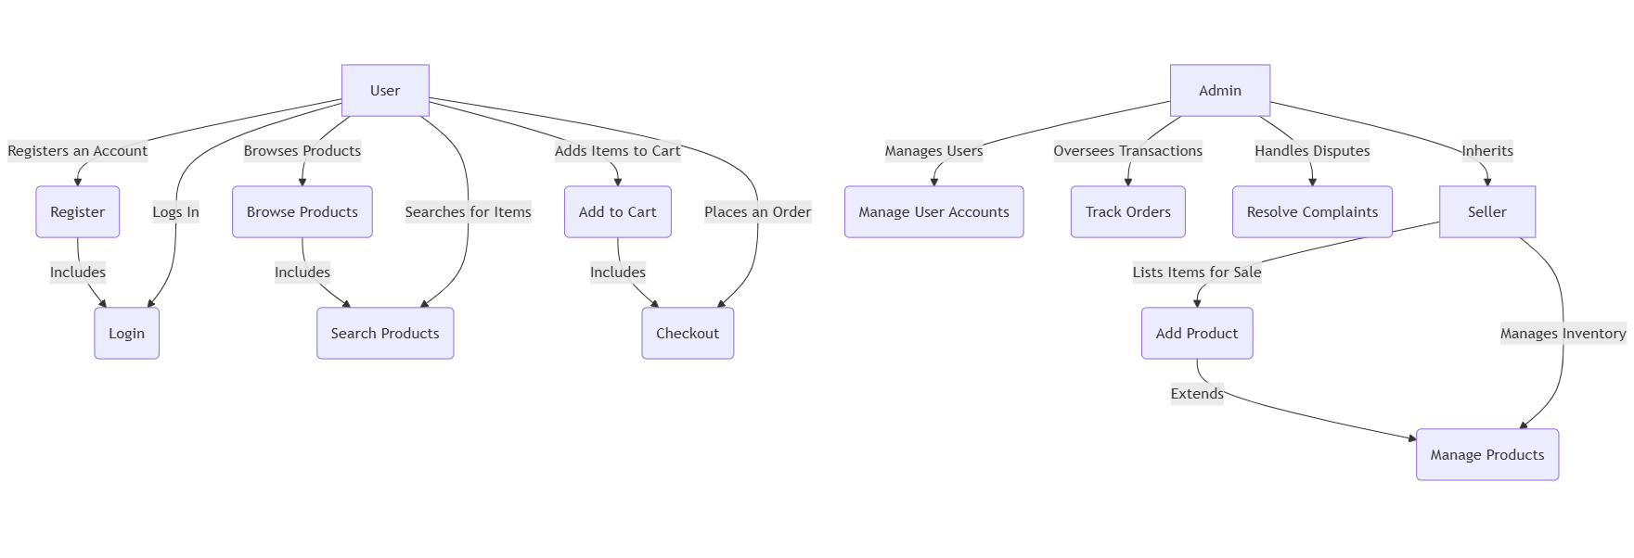

**Use Case Description**

**Buyer**

* Add or deletes to cart
* Checks for notifications
* Contacts Seller
* Pay through the payment gateway

**Seller**

* Creates or register an account as a seller
* Posts products or services
* Checks for orders or notifications from buyers
* Contacts buyer

**Admin**

* System administrator
* Accounts management
* Buyer or seller priviledges

**Sequence Diagrams**

1. **User Registration and Login**

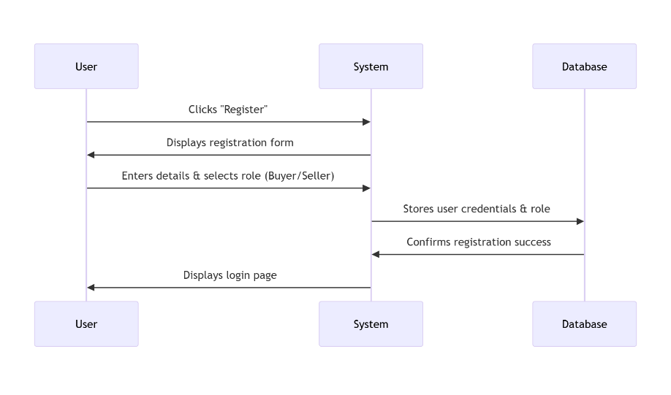

1. **Seller Posting a Product (Category Validation Included)**

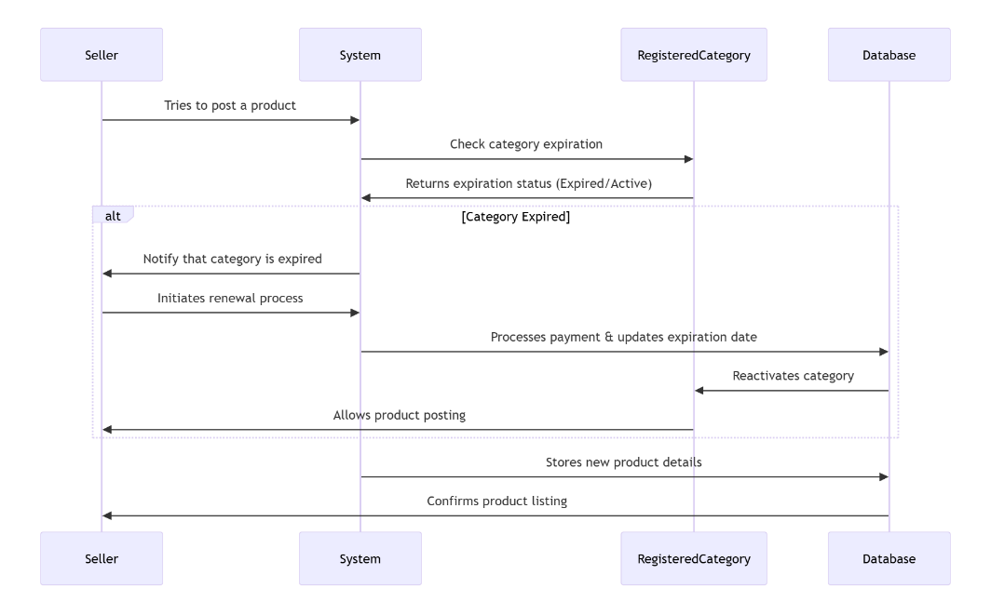

1. **Buyer Searching, & Ordering Product**

Sequence diagram models how buyers search, filter and order items

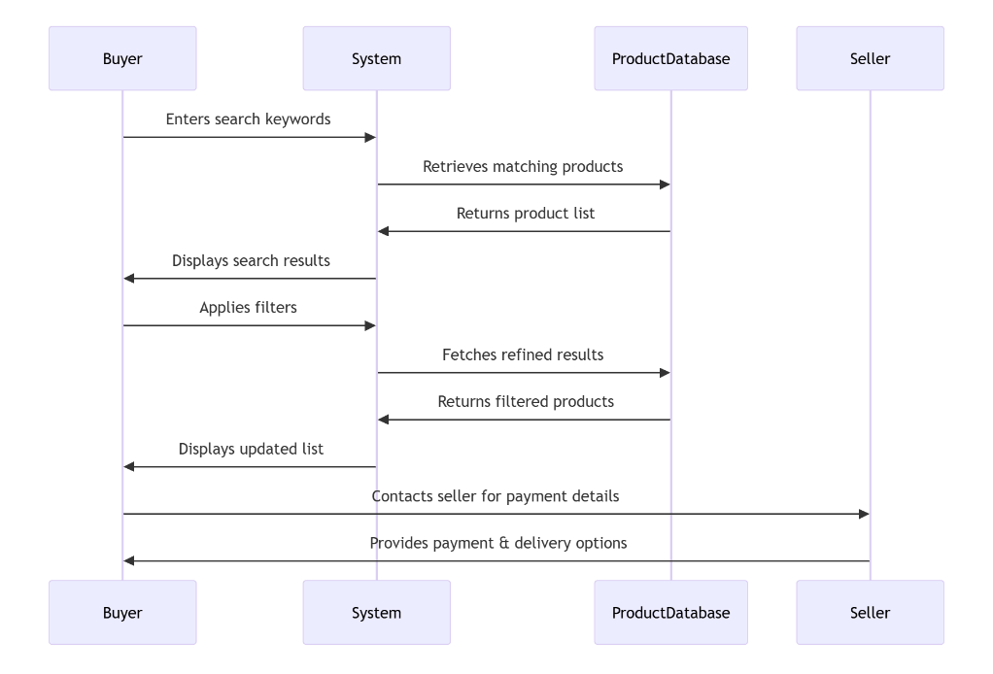

1. **Admin Managing Users and Transactions**

Models how admins oversee transactions and listings

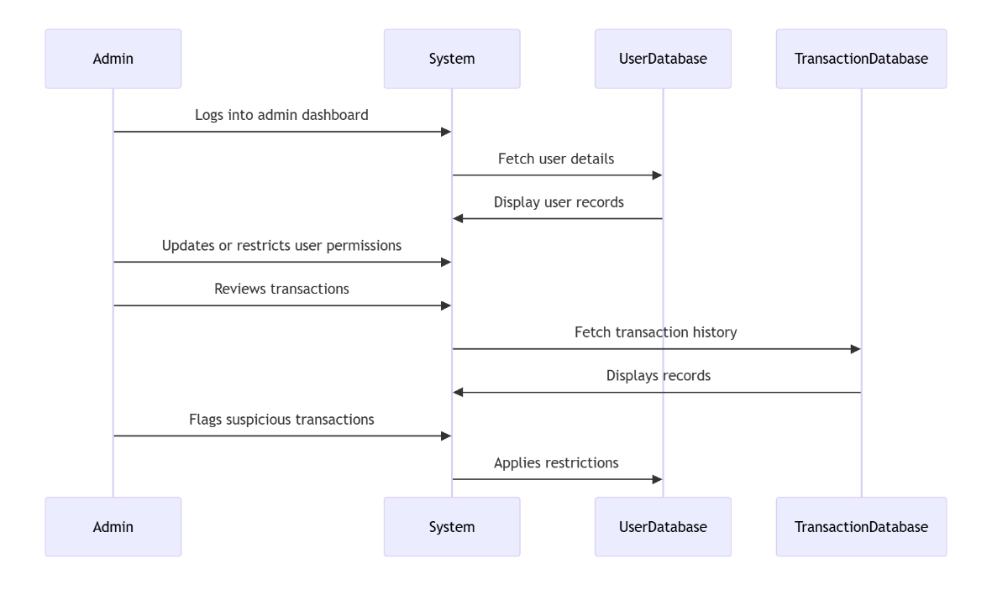

**State chart diagram**

1. **User state diagram**
2. **Product Listing State Diagram**

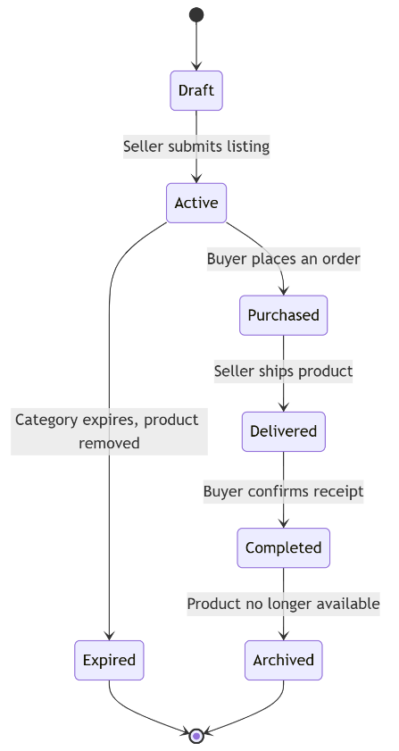

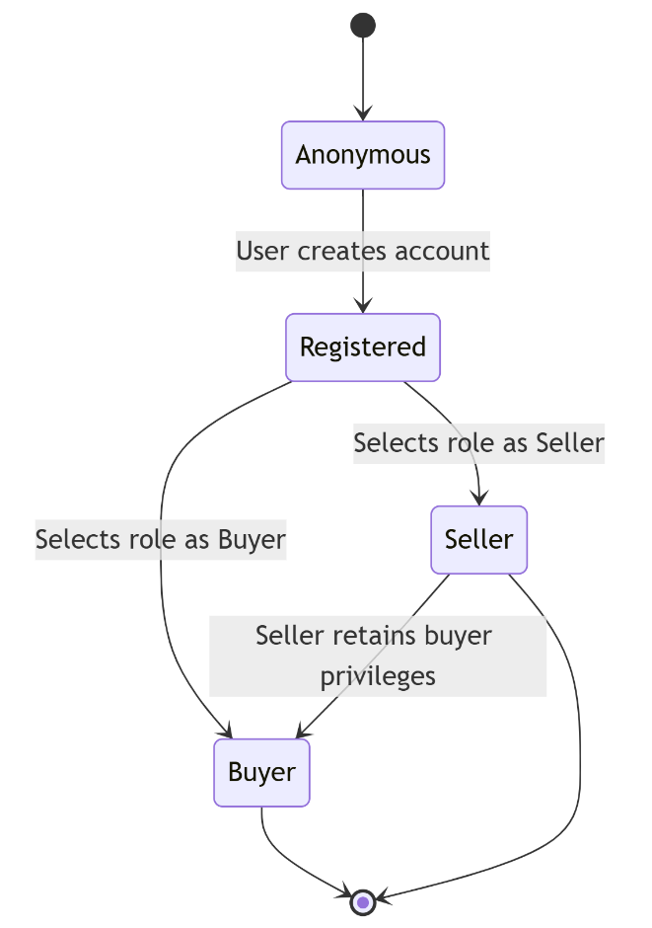

1. **Registered Category State Diagram**

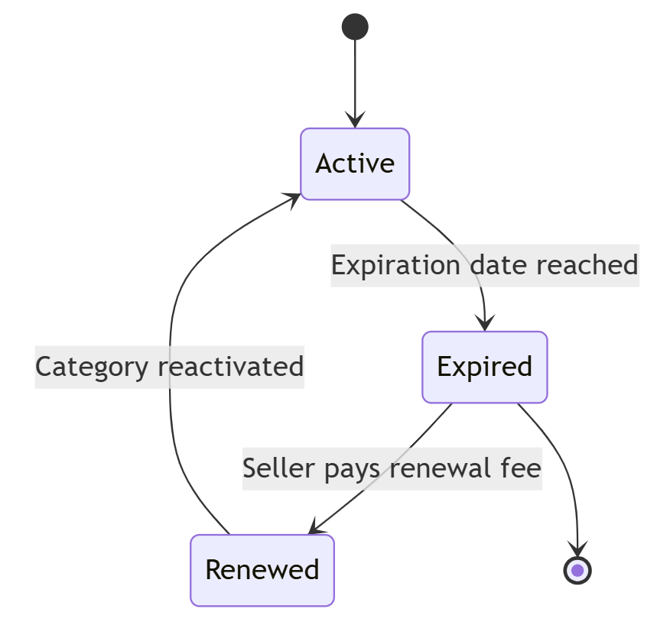

1. **Order State Diagram**

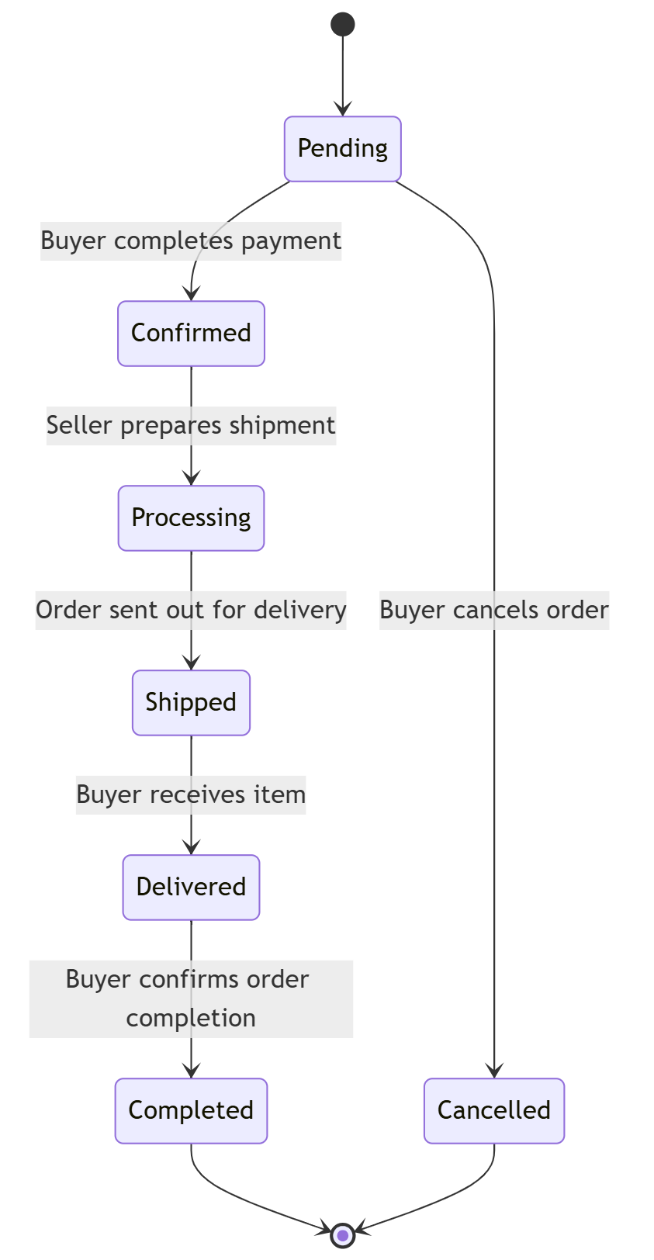

**Activity Diagrams**

1. **User Registration and Role Selection**
2. **Selling a Product**

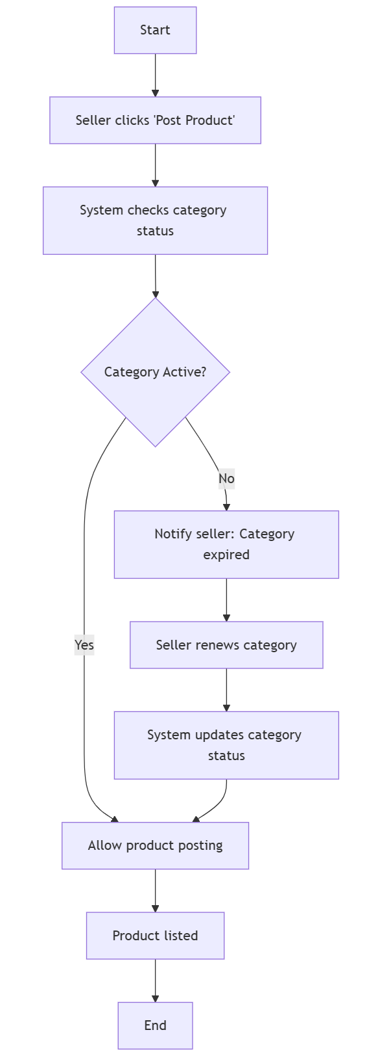

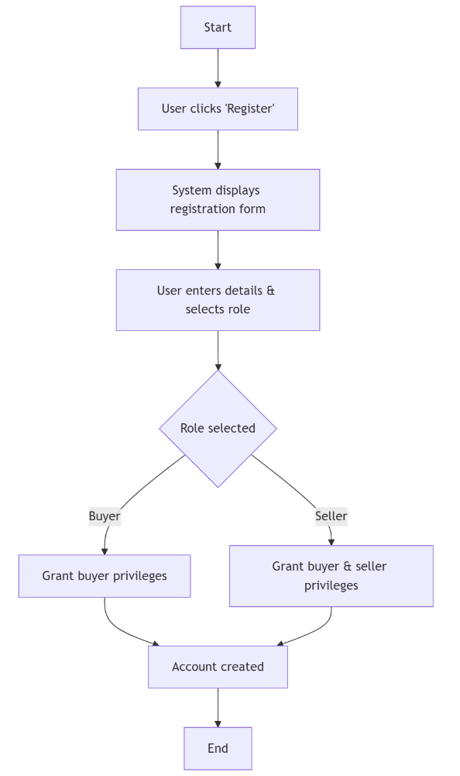

1. **Buyer Searching and Ordering a Product**

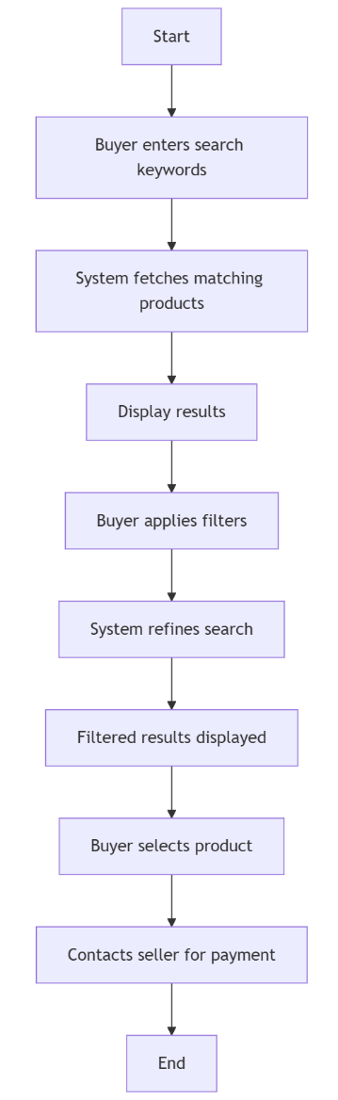

1. **Admin Managing Users and Transations**

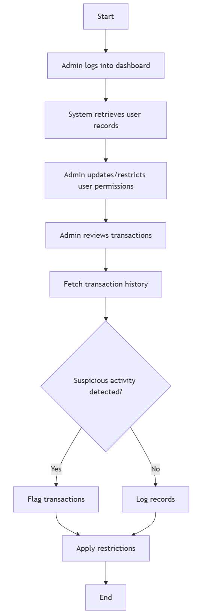

**Key abstraction with Class, Responsibilities, Collaborators (CRC) analysis**

Below are listed the most important classes of the system, clearly defining the responsibilities of each class and how they collaborate with other entities in the system. This has been presented in a way to help identify the objects the system deals with and how they collaborate/interact with each other.

1. **User**
2. **Responsibilities**

* Register and select user type (Buyer/Seller/Admin)
* Manage account details
* Browse, search, and filter products

1. **Collaborators**

* Product
* Order
* Seller

1. **Buyer**
2. **Responsibilities**

* Purchase products
* Contact sellers
* Track order status

1. **Collaborators**

* Product
* Order
* Seller

1. **Seller**
2. **Responsibilities**

* List and manage products
* Buy and renew expired category subscriptions
* Communicate with buyers

1. **Collaborators**

* Product
* Registered Category
* Buyer
* Admin

1. **Admin**
2. **Responsibilities**

* Manage users and transactions
* Moderate listings
* Oversee system security

1. **Collaborators**

* User
* Seller
* Product
* Order

1. **Product**
2. **Responsibilities**

* Store product details(name, category, price, image, seller details)
* Handle availability and status updates

1. **Collaborators**

* Seller
* Category
* Buyer
* Order

1. **Registered Category**
2. **Responsibilities**

* Validate seller’s category registration
* Track expiration and renewal

1. **Collaborators**

* Seller

**Identifying change cases**

1. **Enhancing security with two-facot authentication (2FA)**

* **Potential Change:** Enforce **2FA** during login for both buyers and sellers.
* **Likelihood:** **High** – Security threats make **multi-factor authentication a necessity**.
* **Impact:** **Reduces fraud risks** but introduces a **slightly more complex user authentication flow**.

1. **Expanding to a mobile application platform**

* **Potential Change:** Develop a **dedicated mobile application** for easier access.
* **Likelihood:** **Very High** – Many users prefer **mobile accessibility**.
* **Impact:** Enhances user engagement but **increases development complexity**.

1. **Automated Category Renewal Reminders**

* **Potential Change:** Notify sellers **before** their registered categories expire.
* **Likelihood:** **High** – Sellers may forget renewal deadlines, affecting product listings.
* **Impact:** **Reduces disruptions** in listing availability but adds **notification management overhead**.

1. **Implementing AI-Powered Product Recommendations**

* **Potential Change:** Utilize machine learning to suggest relevant products based on user behavior.
* **Likelihood:** **Moderate** – Enhancing **user experience and engagement** is valuable.
* **Impact:** Increases conversion rates, but **requires additional computing power** for real-time analysis.

**CRC Diagram**

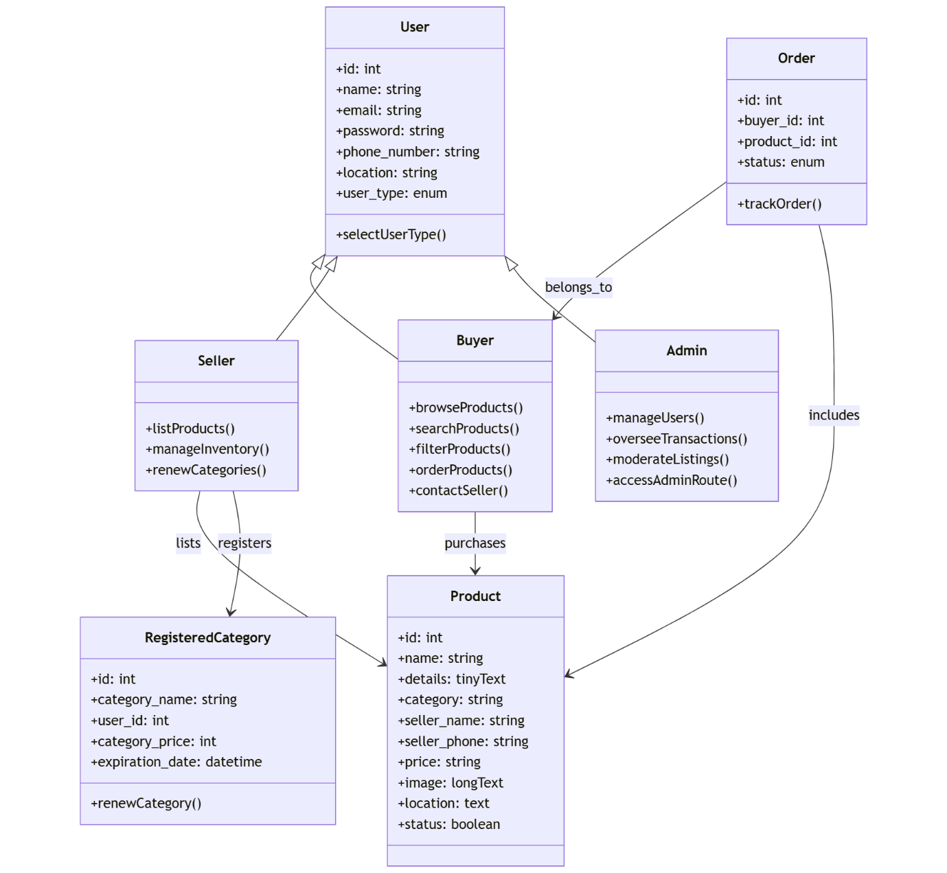

**Conceptual Modelling: Class Diagram**

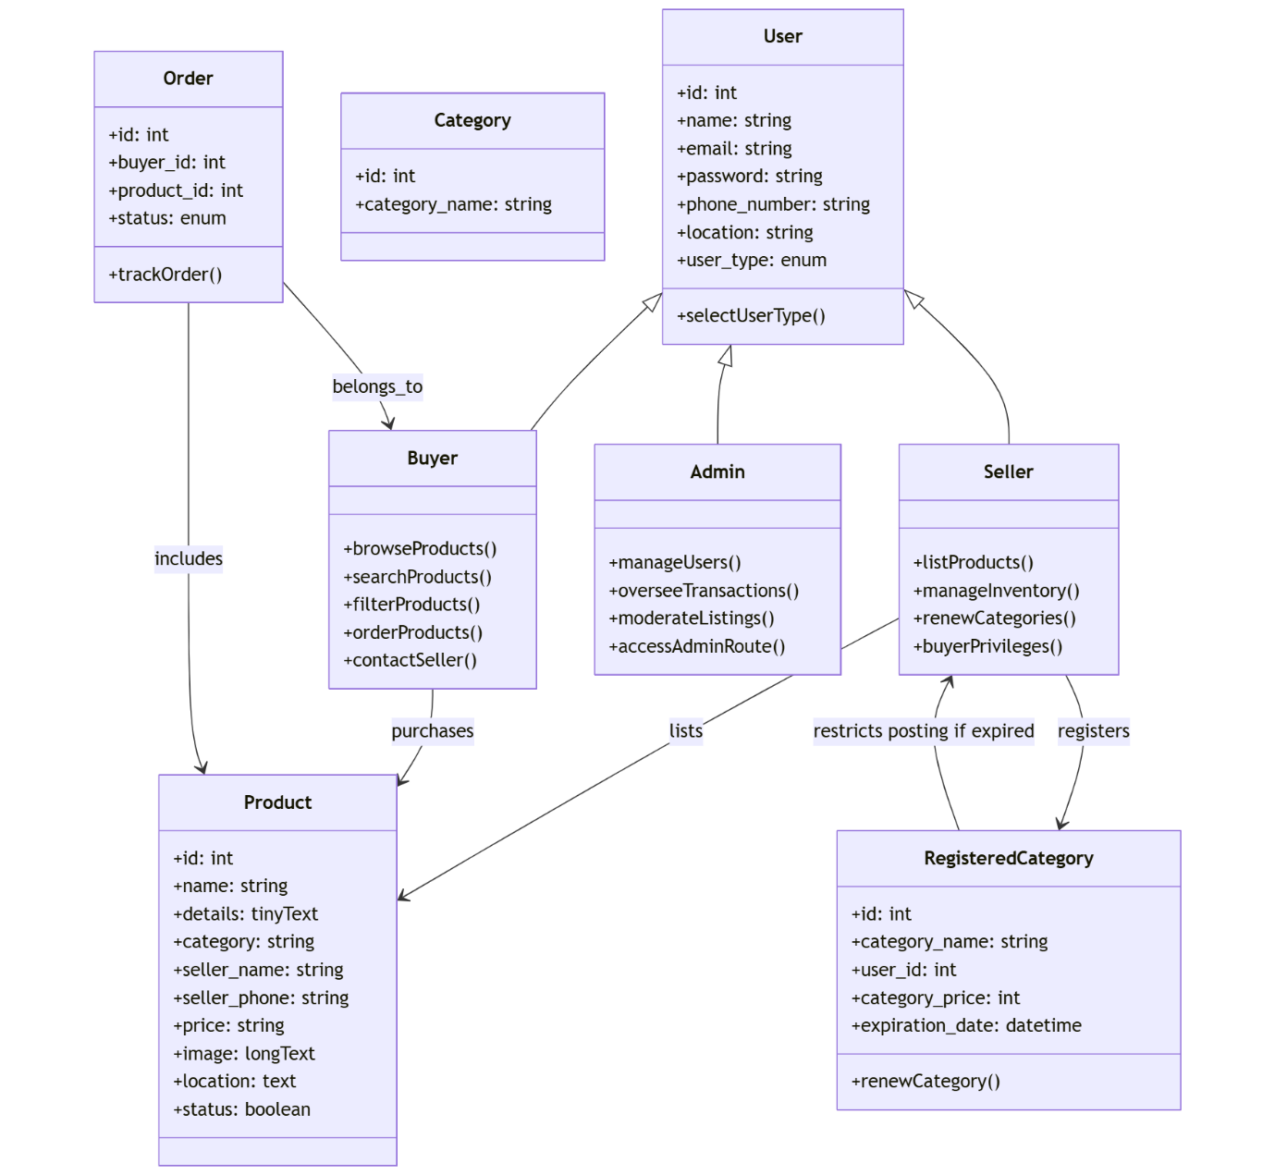

# Chapter Three: Design

This chapter highlights the logical and physical design of the online market place as well as the analytical procedures to be considered

## 3.1 Purpose and goals of design

1. **Practicality**: The system is very practical to traders and service providers as it seeks to offer a market place for the set of audiences(users) corresponding to an online market place platform
2. **Accuracy**: The ADVENTIST ENTREPRENUERS online market place is designed in such a way that fulfils nearly all requirements around which it is designed. It is meeting the functional or non-functional requirements.
3. **Completeness**: As far as the developer is concerned, the system design has met all the user requirements for which it has been developed for.
4. **Efficient**: Currently the system design is not overusing surpassing the cost of resources allocated. It is a cost effective system
5. **Reliability**: The system designed is in proximity to a failure-free environment for the period till faults are witnessed with time.
6. **Optimization**: Time and space have been moderately consumed for individual components that are part of the system.
7. **Scalable (flexibility)**: The online market place system is adaptable with time as per different user needs of customers which we know will keep on changing on time.

## 3.2 Current software architecture

Currently the ADVENTIST ENTREPRENUERS relies on social media platforms for marketing, selling and coordination of trade activities. The mainly used platforms are WhatsApp business groups, Facebook, channels and groups. People post their products on such social media platforms and information is just random.

**Drawbacks of the current system**

1. Information is random and does not follow any order
2. Information can easily be missed or skipped due to high traffic, especially for WhatsApp messages
3. There is a limitation in trying to make sellers meet buyers
4. Some of the platforms are not responsive

**Current Business Rules**

1. Group admins control the flow of information
2. Information is not sorted and properly controlled

## 3.3. Proposed Software Architecture

**Subsystem decomposition**

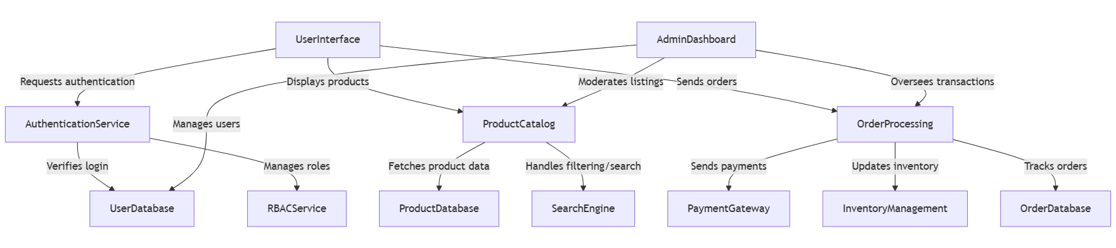

**Deployment diagram**

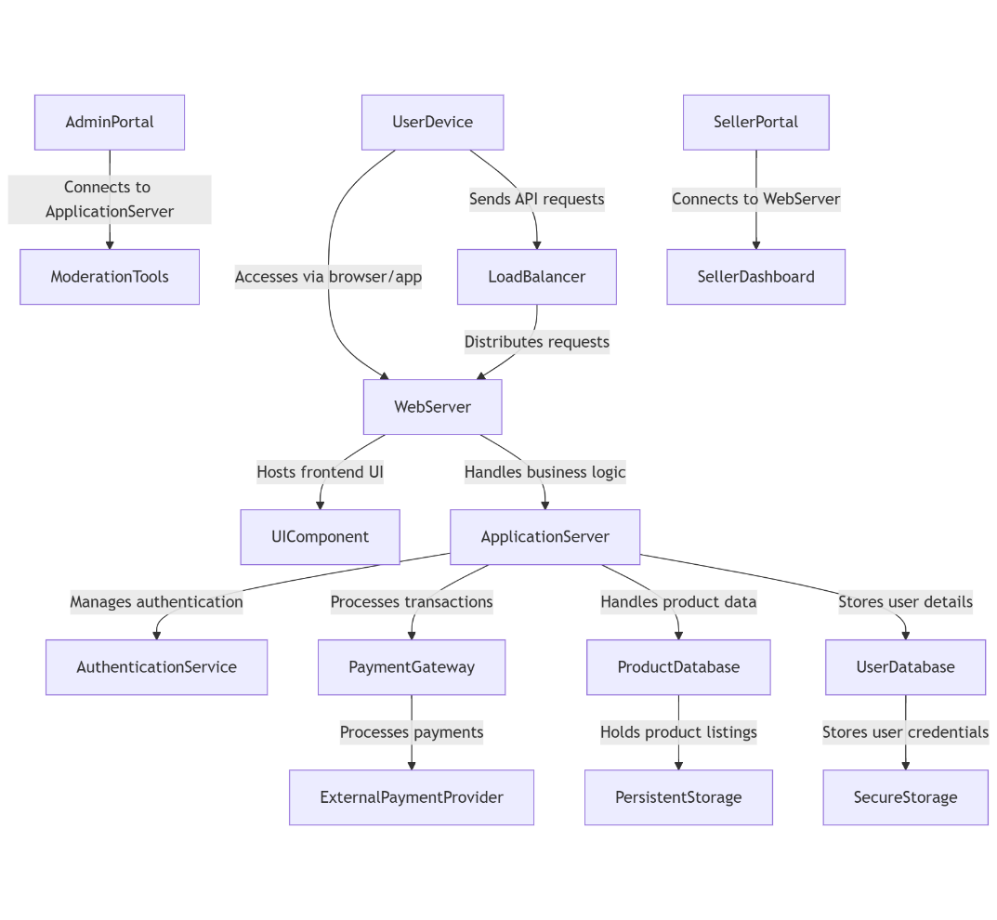

**Key features**

* **Distributed Deployment** – **Frontend UI**, **application logic**, and **databases** run on separate components.
* **Load Balancing for Scaling** – Distributes **API requests efficiently** to maintain system performance.
* **External Payment Processing** – Payment requests are securely routed to **external gateways like Stripe or PayPal**.
* **Secure User Data Storage** – Enforces **RBAC access control** and **encrypted user credential storage**.
* **Portals for Different User Types** – Admins, sellers, and buyers interact through **dedicated access points**.

**Database design (ER diagram) for relationalship database**

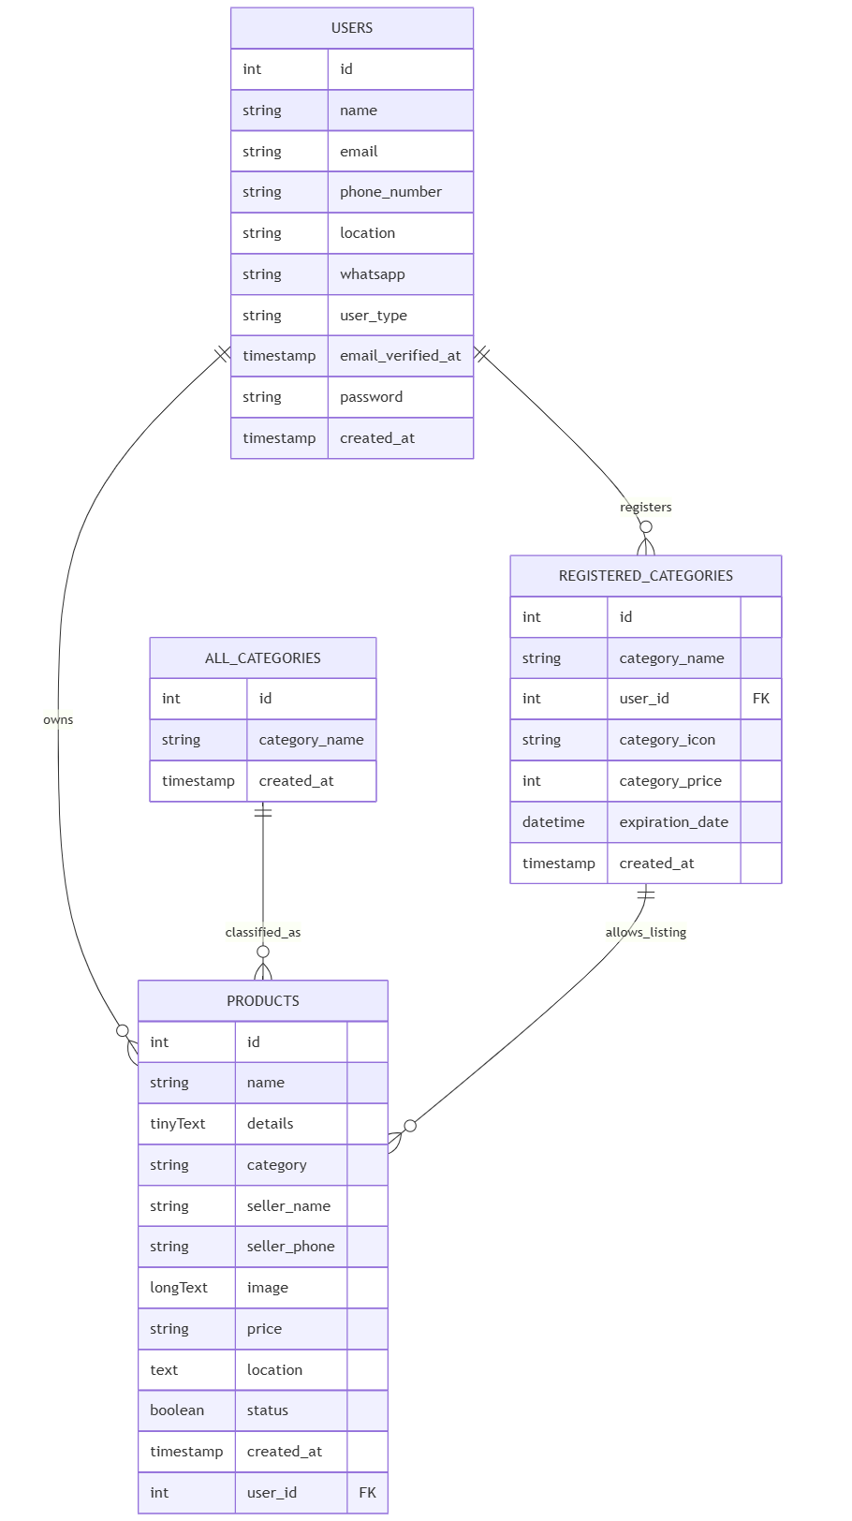

**Key Considerations**

* **User Roles Defined** – Each **user can be a buyer, seller, or administrator**.
* **Products Belong to Categories** – Sellers must **register categories before posting products**.
* **Category Expiration Enforced** – **Sellers cannot list products in expired categories**.
* **Foreign Key Relationships Maintained** – **Product listings depend on user ownership**.
* **Database Integrity Maintained** – **Cascade delete and update constraints** ensure consistency.

**Access Control and Security**

The Role-Based Access Control (RBAC) system ensures that different actors, buyers, sellers, and administrators, have appropriate access to features, functionalities and data based on their roles.

**User Roles & Priviledges**

1. **Buyer**

* **(Allowed Access)**
* **Browse, search, and filter products.**
* **Place orders and track deliveries.**
* **Contact sellers for inquiries.**
* **Manage profile and payment information.**
* **(Restricted Access)**
* Cannot list produts for sale
* Cannot modify or delete product listings

1. **Seller**

* **(Allowed Access)**
* **All buyer priviledges**
* **Post products within active registered categories.**
* **Update, modify, or delete listed products.**
* **Manage inventory and pricing.**
* **Renew expired categories before listing new products.**
* **(Restricted Access)**
* Cannot access buyer order details beyond their own sales
* Cannot modify other sellers’ product listings

1. **Administrator**

* **(Allowed Access)**
* **Manage users** (suspend, delete, modify accounts).
* **Monitor transactions** and flag suspicious activity.
* **Oversee product listings** for compliance.
* **Manage payment records** and refund processes.
* **Review reported disputes** between buyers and sellers.
* **(Restricted Access)**
* Cannot **purchase or sell** products within the system.
* Cannot **change seller prices unless violations occur.**

1. **Access Control Mechanisms**

* **Authentication & Authorization**
* Users authenticate via **email & password login** before accessing functionalities.
* Role-based permissions restrict access to unauthorized features.
* **Category-based selling restrictions**
* Sellers **must renew expired categories** before listing new products.
* **Admin moderation & auditing**
* Admins can suspend malicious users based on fraud detection.
* **Data Protection Measures**
* Sensitive user data is encrypted (password, payment records)

1. **Secure API & Access Logging**

* Every API call checks **user roles** before executing operations.
* **Activity logs track modifications** (e.g., deleted listings, transactions).
* **IP-based access restriction** for administrative controls.

# Chapter Four: Implementation

# Chapter Five: Testing and Evaluation

## System Testing

Testing is an essential part of the validation process. System testing is the method of practicing or assessing a system or system element by manual or automated means to check that it meets the defined criteria or to detect gaps between the anticipated and actual outcomes. In this regard, validation is the software evaluation method to guarantee compliance with software requirements at the end of the software development phase. In addition, it is assessing the system’s ability to deliver what is intended to produce, system is measured with its objectives. The diagram below shows steps that we followed in testing.

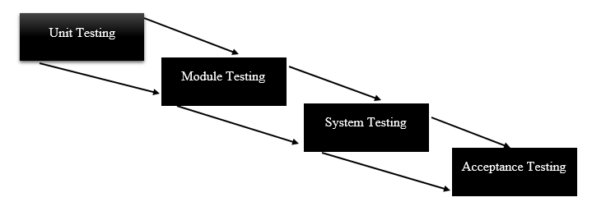

*Fig 5.1 System testing flow process*

For the ADVENTIST ENTREPRENUERS ONLINE MARKET PLACE system, testing has been done in various forms to make sure the system meets its requirements considering various environments and conditions

**1.** **Usability Testing** – the system proved to be easy to use and is flexible in handling controls and has met the objectives of trading between buyers and sellers

**2. Load Testing** – through implementing on the web servers, the system has performed well under real-life loads.-software modules for the period to date

**3. Recovery Testing** – the software solution is reliable, trustworthy and can successfully recoup from possible crashes.

**4. Migration Testing** – the developer has tested and evaluated that the software can be moved from older system infrastructures to current system infrastructures without any issues.

**5. Functional Testing** – The developer engaged the system owners and the functional requirements are being addressed by the system as well as the non-functional ones. There has been no noted possible missing functions.

**6. Hardware/Software Testi**ng – The developer has checked interactions between the hardware and software during system testing. There is a great coherence.

* 1. **Unit testing**

According to Hamilton (2015), unit testing is a product advancement process in which the littlest testable parts of a system, called units, are exclusively and autonomously investigated for appropriate operation. Unit testing should be possible physically yet was frequently automated. In addition, it is when individual component of a system is tested to uncover errors that might not have been recognised during desk checking, all possible situations should be tested for and the unit should contain correct data. There are two categories used for unit testing which are white box or logical testing and black box or functional testing. An example is that the system should verify the user email, as in screenshot below:

* 1. Module testing

It is the testing of dependent component of the system, testing can be done on a single component without other components and in this case, testing is done according to the desired outcome of the module. It is a very important to test as it tests the interfacing modules. In this case, module testing was used to term testing done on fully assembled component as a single system. It was anticipated that defective components could not be isolated during module test and that as result no rework could be performed based on failure during module test, (Hughes, 2017).

* 1. System testing

According to Kuinam (2019), system testing focuses on the whole system ability to meet the specified functions, it involves the coordination and the interaction of all the elements of the system. The integrated components will now be tested for errors as a single unit. Major functionalities are security and ability to produce desired output. Also, the compatibility of the software on the available hardware will be tested and possible threats are looked at with software ability to adapt to threats.

* 1. Acceptance testing

Schreiner (2019), describes acceptance testing as the process when the actual system is delivered to the actual users of the system who test it on the hardware that it is supposed to run on and the actual data that will be dealt with during the entire life of the software. It is the last stage of testing and once it is successful the system will be ready for deployment for full operational use. The system will be tested with data that will be entered by the miners to make sure that the system is working as required by the specifications. The actual users will review errors and difficulties in the system. Acceptance testing comprise of alpha and beta testing. Alpha testing is a sort of testing that is done to distinguish every one possible issue before distributing the application to general users, it takes place at the developer's site by the internal teams before release to external users. Beta testing is designed to safeguard that the product is ready for release by distributing it into the real world and getting response, (Sommerville, 2020). It was done by mine workers of the application system in a real situation and could be well-thought-out as a kind of external user acknowledgment testing. It decreased application dissatisfaction dangers and gave expanded nature of the application through mine workers approval. Screenshot below shows the application’s dashboard after user log in:

* 1. Testing strategies

A testing procedure was a general way to deal with the testing processes as opposed to a technique for formulating specific application or part tests. Distinctive testing techniques might be embraced depending on the kind of application to be tried and the improvement procedure utilized. The strategies used are: Validation, Hamilton (2015) states that the main objective of validation is to check if we are developing the right system which solves the intended problem; it is tested through the data that is entered and the output. It is for ensuring that the correct and desired data is entered in order to produce desired output. Validation bAdventist Entreprenuerscally checks the entered data in the text box to see if it is correct to the specified field type. This form was tested for validation of the user email and password:

* 1. Verification

It is reviewing, inspecting and testing for establishment and documenting the product. It is ensuring that the system meets technical and regulatory standards or whether the system was built conforming to required standards. It strives to answer the question as to whether the system is meeting its functional requirements. In conclusion verification reveals that the system was validated correctly and meets specific objectives. For example, screenshot of logout dialog box as below:

* 1. Installation

Alexander (2014), ascertain that it is the procedure of linking, setting and creating the application ready for implementation. The procedure of alignment and installation was engaged with sub activities to it. These activities included user training manuals, and reference as in where it will be placed such that it could be retrieved by all the expected users.

5.4.1 Installation procedure of the android application

Steps to be taken

1. First make sure the android version is 5.0 and above
2. Download application
3. Click on the application
4. Select install and after installation
5. Click finish
6. Open the application and sign up first to start using it.
   1. Maintenance

Due to the dynamic world of business a system needs to be reviewed and updated to ensure that the system continues to cope up with changes. Maintenance is carried out after the system is delivered, periodically usually monthly to make sure that the changes in demand are met by the system. Sommerville (2015), points out that maintenance is the fact of assuring that the system is acting admirably, distinguishing requirement for alterations regarding working there might be recognized adjustments that may be seen during the maintenance procedure. They are four types of maintenance which are perfective, adaptive, preventive and corrective.

* 1. Perfective maintenance

Krugman (2016), stated that perfective maintenance involves improving performance in processing of the system hence adding the desire to use the system. It is more like development of a new software because some features will not be necessarily needed. It is concerned with add-ons to the system to add extra value and efficiency giving room for improvements. Perfective maintenance will be done after every six months and some features would have upgraded.

* 1. Adaptive maintenance

Adaptive maintenance is carried out so that the application adjusts to changes that are to transpire in its process. Due to technological changes, the system should be capable to adjust to any alterations, (Sommerville 2015). The need for adaptive maintenance can only be identified by controlling the environment. Adaptive maintenance is to be carried out every time the application changes the environment. Mostly changes in hardware and operating system results in adaptive maintenance.

* 1. Preventive Maintenance

According to Krugman (2016) preventive maintenance are activities that involve application alterations leading to better functional aspects of the software. It will be implemented to improve performance, accessibility and other features of an application. Preventive maintenance will be done every week to make sure the application is continuously meeting the requirements of users.

* 1. Corrective Maintenance

Valacich (2014), stated that corrective maintenance encompasses changing a software system to eliminate errors. The major causes of maintenance are design errors, coding errors and logic errors which were encountered during the system design and is done unpredictably because there is no knowledge when the system is going to fail. Corrective maintenance is done in three steps: diagnosing the problem, repairs and replacements of faulty component and verification of the repair action.

* 1. Recommendation on maintenance strategy

Preventive maintenance has ended up being convincing from the researcher’s point of view because it deters the system from breaking down by performing maintenance regularly instead of conducting maintenance when failure has occurred. It is used to maximize an assets useful lifetime and minimise costs, its purpose is to avoid unscheduled or unplanned breakdowns. There is less risk factor because the system will be checked regularly therefore creating a safer system for the workers. It keeps the software up and running for a long period of time and long-term repair costs are usually significantly lower however, preventive maintenance may be too costly when initially starting it than it would be if there is breakdown

* 1. Chapter Conclusion

The development of a responsive online market place for ADVENTIST ENTREPRENUERS in overall, if implemented and tested for a prolonged period can allow for improvement in the institution as a whole. This whole chapter has explained the whole implementation phase for the application.